https://academic.oup.com/ajae/article/101/1/193/5051676?utm_source=chatgpt.com&login=false

Is corn less or more susceptible to drought than other crops?
How much of an effect does irrigation have on drought?
-Could be that irrigation just always has a positive effect on crop yields?
-Why would a farmer not irrigate all crops?
How to control for improved yield due to technology (e.g. tractors and fertilizer)?
Are droughts becoming more common and if so, by how much?
Are there better types of irrigation systems?
How does temperature affect crops?
Does the region matter - specific regions more affected by drought?
Could it be the length of a concurrent drought is more significant than the total weeks of drought?
Does when the drought occurs matter (e.g. during the growing season)
Note: lower crop yields typically don't affect farm income significantly since higher scarcity raises prices and farmers may store product during high yields and low prices and sell the product during low yields and high prices

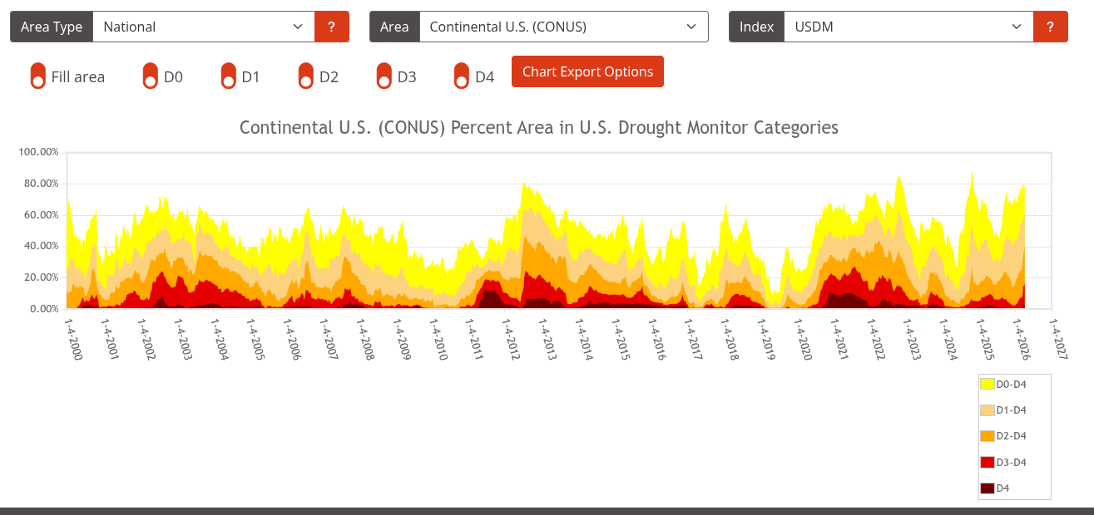
https://droughtmonitor.unl.edu/DmData/TimeSeries.aspx

